Help for depression in the Montreal area

Youth-Oriented:
- Herzl Family Practice Center –Adolescent Clinic: 514-340-8242

- Montreal Children's Hospital:
514-412-4400
Ext. 23295
*Referral needed (call your local CLSC first. Dial 811 to find your local CLSC)

- Head and Hands: 514-481-0277
www.headandhands.ca

- Kids Help Phone: 1-800-668-6868
www.kidshelpphone.ca

General:
- Emotional Health CBT Clinic:
514-485-7772
www.cbtclinic.ca/treatment

- Suicide Action Montreal:
514-723-4000
www.suicideactionmontreal.org/

- PsyMontreal: 514-337-2473 Ext. 0 http://psymontreal.com/

To Learn More

Websites:
- www.amiquebec.org/depression/
Resources for depression

- http://www.nami.org/Learn-More/Mental-Health-Conditions/Depression
Symptoms, causes and diagnosis of depression

- www.nimh.nih.gov/health/publications/depression/index.shtml
Types of depression

- http://www.helpguide.org/mental/depression_tips.htm
Dealing with depression

AMI-Québec has many programs to help families and people suffering from mental illness. If you recognize yourself or someone you care about in this pamphlet, please contact us and we will direct you to an appropriate resource.
(514) 486-1448 www.amiquebec.org outreach@amiquebec.org facebook.com/AMIQuebec @AMIQuebec

DEPRESSION

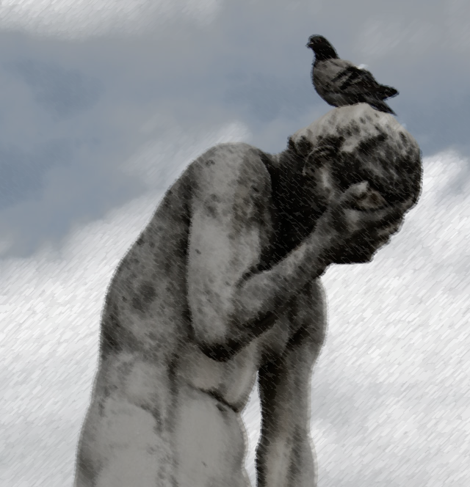

AMI-QUÉBEC
Action on Mental Illness

5800 Décarie Blvd.
Montréal, Québec H3X 2J5
(514) 486-1448
outreach@amiquebec.org
www.amiquebec.org

Mary was the editor of her high school yearbook and she was on the graduation committee. Her marks were above average and her friends and teachers liked her for her outgoing personality and her cheerfulness.
When Mary started staying in bed until late afternoon her parents figured that it was due to her busy schedule. When her grades started slipping, they attributed it to all her extracurricular activities. After all, she seemed fine.
Then why did she feel awful inside? All she wanted to do was sleep and cry. Every day was an effort to put on a happy face. When teachers thought she was concentrating on her work, she was really dreaming of ways of ending her life. Was she so weak that she couldn't make herself feel better? What kind of person was she? Nobody, she believed, would understand her, so she didn't say a word.

DEPRESSION
Depression can appear at any age and is one of the most common and treatable mental illnesses. Up to 9% of the population will experience depression at some point during their lifetime. Nearly everyone who receives treatment benefits from it. However, many people fail to recognize the symptoms and don't get help because they think their depression is a sign of weakness. Others are told to make themselves "snap out of it" or just "get over it."

TYPES OF DEPRESSION
- MAJOR DEPRESSION is a mood disorder characterized by feelings of sadness, loss, anger, or frustration that interfere with daily life. Symptoms may last for months. Left untreated, depression tends to reoccur.
If you are having persistent thoughts of suicide get help immediately
- DYSTHEMIA is a mild, long-term depression that can go on for years. A person will be functional but always be "down in the dumps". They are not

able to enjoy life and may feel

inadequate, gloomy, and negative.
Depression can be accompanied by anxiety, panic, and paranoia. These symptoms can be scary, but once the depression is properly treated, they tend to diminish and may disappear altogether. Following is a list of warning signs for depression:
- Too much or too little sleep
- Eating more or less than usual
- Agitation (anxiety or worried)
- Loss of interest in friends, hobbies, or school
- Loss of energy; fatigue
- Feelings of worthlessness, guilt, self blame, or hopelessness about everything
- Difficulty concentrating
- Loud, obnoxious, anti-social behaviour or unusual risk-taking
- Violent outbursts and lack of self-control
- Use of alcohol or drugs to feel better
- Unexplained aches and pains
- Thoughts of death and suicide
If several of these symptoms last for more than 2 weeks then seek medical help.

HOW TO APPRAOCH SOMEONE WHO MIGHT BE EXPERIENCING DEPRESSION
- Do not be afraid to talk about it; silence makes it worse
- Encourage the individual to talk to you
- Offer them support
- Be a good listener
- Do not treat them as if they are different or weak; be compassionate and understanding
- Do not be over-protective or over-involved; this will make things worse
GETTING HELP
If you or someone you know shows signs of depression then it is important to get help. The sooner an illness is treated, the better the outcome. Telling friends is not enough. It is important to talk with an adult whom you trust: a parent, guidance counselor, social worker, coach, or teacher. You can also visit a family doctor or CLSC and explain what you are experiencing.

